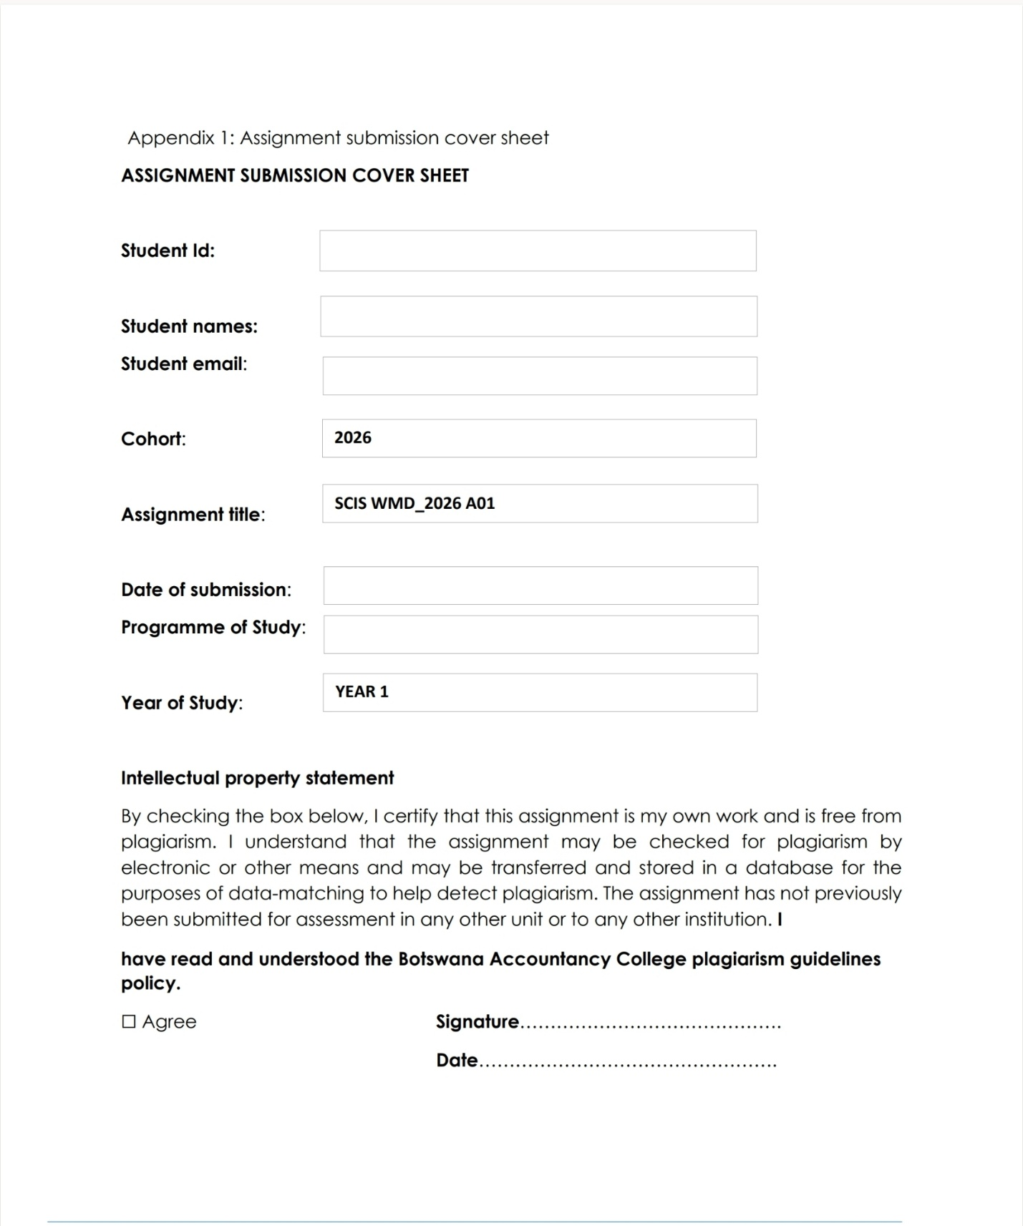
Business Intelligence & Data Analytics
bida25-194@thuto.bac.ac.bw
Lame Zinzi Pontsho
BIDA25-194
ROVE CRAFTS WEBSITE
Introduction
Rove Crafts is a start up business that specializes on handmade crocheted bags and accessories created from t-shirt yarn. T-shirt is a form of chunky yarn made from recycled textiles. To reduce the physical pollution created by traditional print media such as flyers and printed catalogues Rove Crafts uses social media as a means of communication and advertisement.
- Website Specifications

  - Objectives

This website's primary aim is to inform. I am creating this website as a catalogue and reference point for Rove Crafts. According to (Lou & Koh, September 2018) there is more interactivity and vividness in websites as compared to traditional media such as magazines. The website will be a professional upgrade which will allow for potential customers to get information anytime and anywhere with internet access and ask questions if any.

  - Target Audience, Demographics & Technical Aptitude

The website targets 18 to 30 year olds, which are the main market for Rove Crafts. This group consists of the younger workforce and gen-z students within Botswana. According to (Sponcil & Gitimu, 2013) 57% of social media users are aged between 18-29 years old. Rove Crafts is for people that are experimental with their aesthetics and value sustainability. As stated by (Muralidhar & Dr Raja, December 2019)gen z is most likely to purchase products online as they spend most of their time browsing the internet.

The website is a way to communicate with potential customers, inform them about products, deals and promotions. Over 90% of people use social media to access information, (Arafah & Hasyim, January,2022). The people of the aforementioned demography are very digitally literate. Therefore, the website should be of high performance and have a mobile responsive design.

  - Type of Website/Content

This is a catalogue website. It is highly visual with multiple images and video animations to engage the user. Since Rove Crafts operates on a “DM to order” basis, the website serves to inform the customers of the products specifications, current deals and promotions, before directing them to WhatsApp where they can place their orders.

- Information Design & Taxonomy

  - Site Map

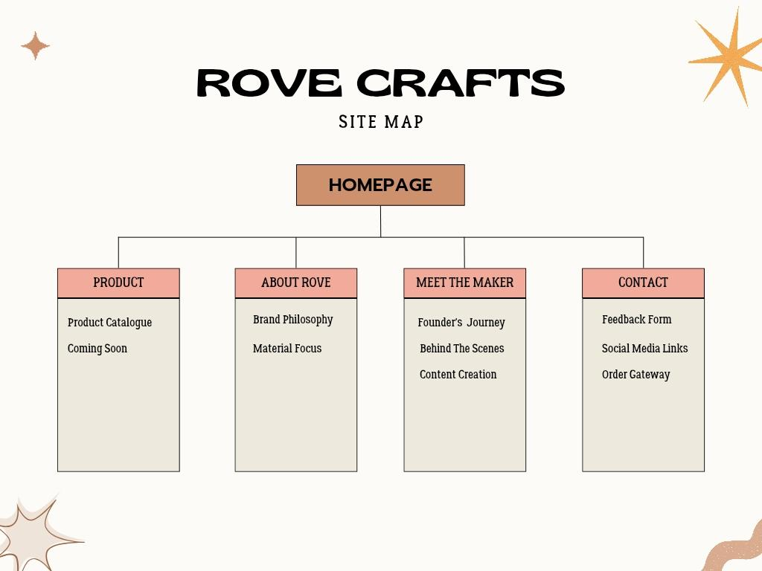
Figure 1: Rove Crafts Site Map (Created in Canva)

The site map for Rove Crafts follows a hierarchical structure. By categorizing the website into 4 pages; Product, About Rove, Meet The Maker & Contact, the user can easily access any information with a single click from the home page. There will be a navigation panel on top of each page to easily access other pages no matter the page one is on.

  - Storyboard Flowchart

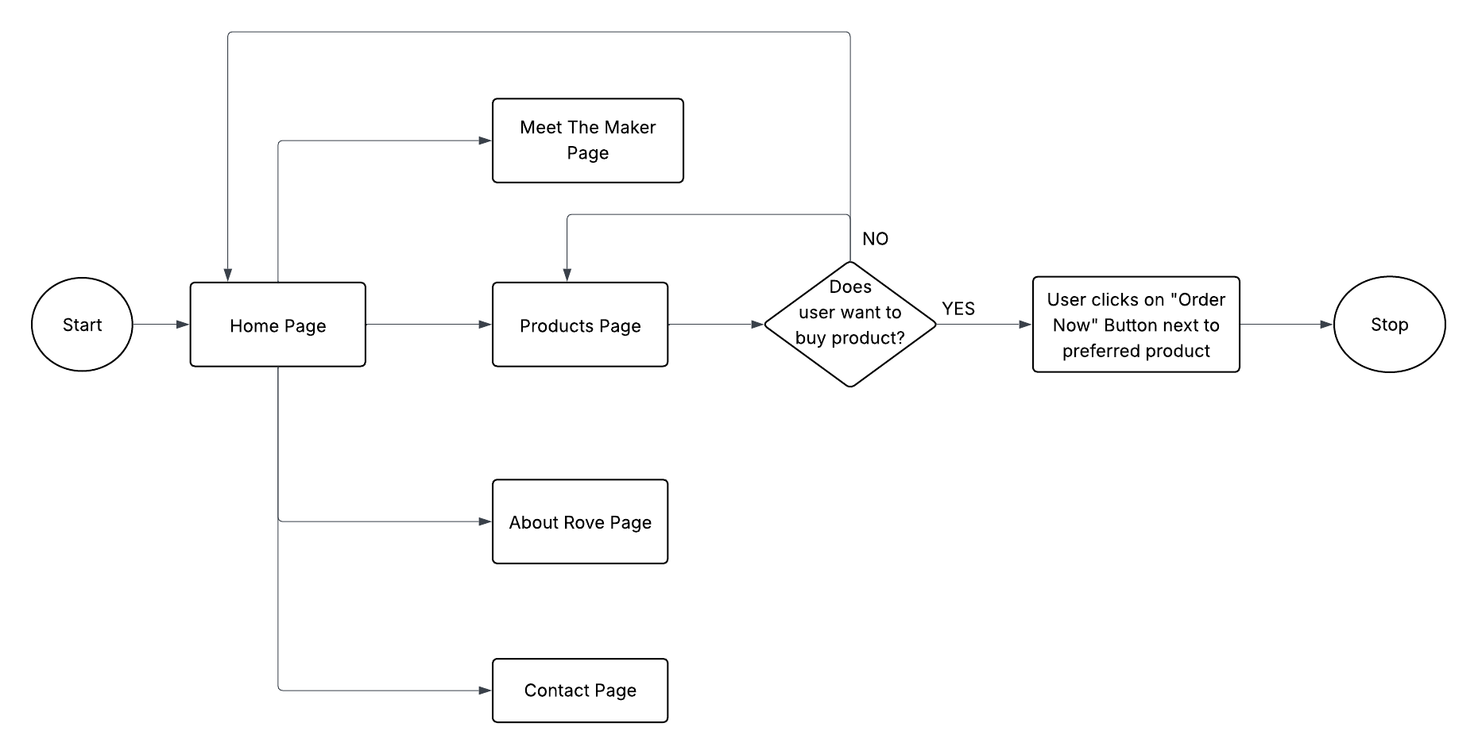
Figure 2: Rove Crafts Storyboard Flowchart (Created in Lucidchart)

The storyboard illustrates the navigation through the website. It is designed for high engagement and low friction. Upon landing on the home page, a welcome video automatically plays and the user is presented 3 different pages as well as a global navigation bar that has all the pages they can explore.
Assuming the user is interested in making a purchase, they can simply click on the products page. There they view the catalogue which has all products available along with their prices and short descriptions. Besides each product is an ‘Order Now’ button which the user presses to place an order.
The button will then direct the user to a WhatsApp chat where they will have a 1 on 1 consultation with ‘The Maker’ (the owner) and place an order on the agreed terms.
If the user is just interested in knowing about the brand philosophy, they could click the About Rove page and if they are interested in the owner’s journey, they could click on the Meet The Maker page. The Contact page is where they click if they want Rove Crafts’ other social media links, a feedback form and the order gateway.

- Page Template Design
All page template designs were made with visual paradigm
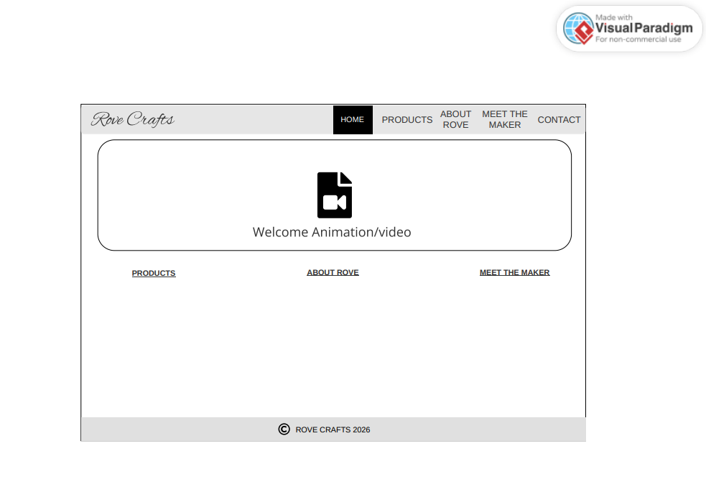
Figure 1: home page

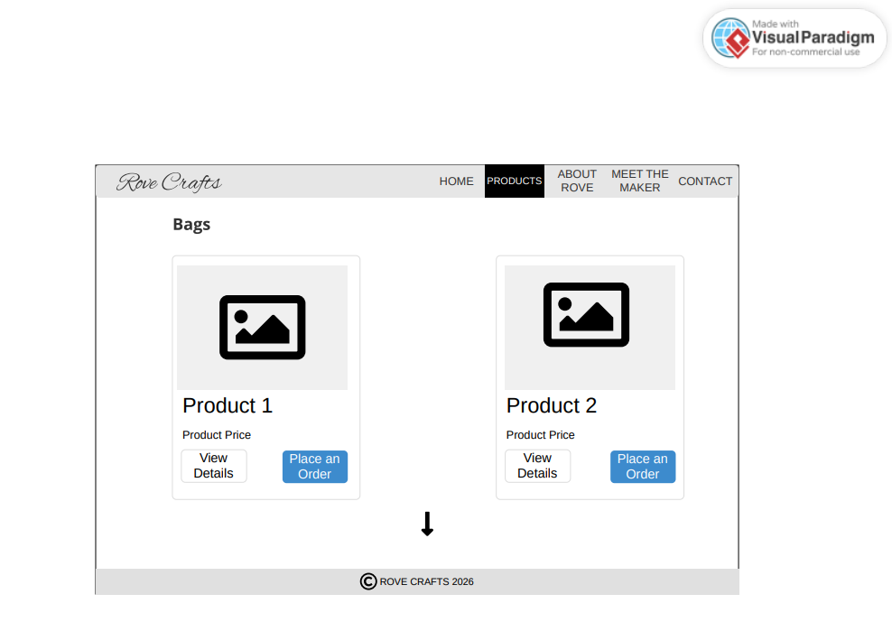
Figure 2: Products Page
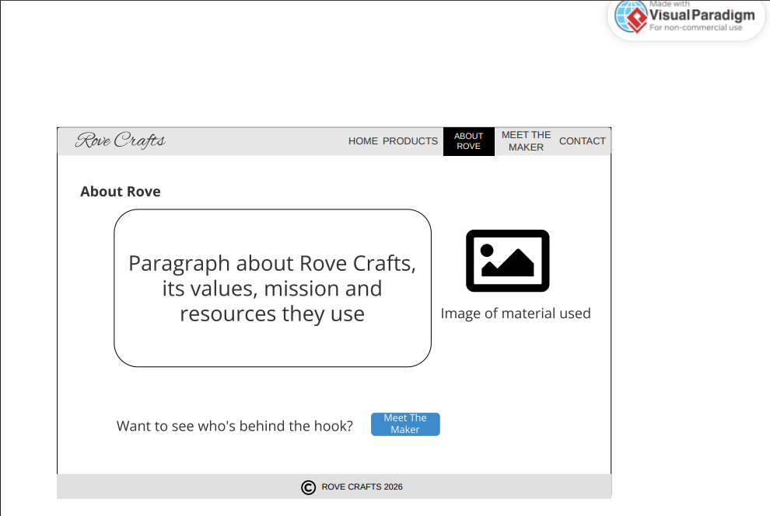
Figure 3: About Rove Page

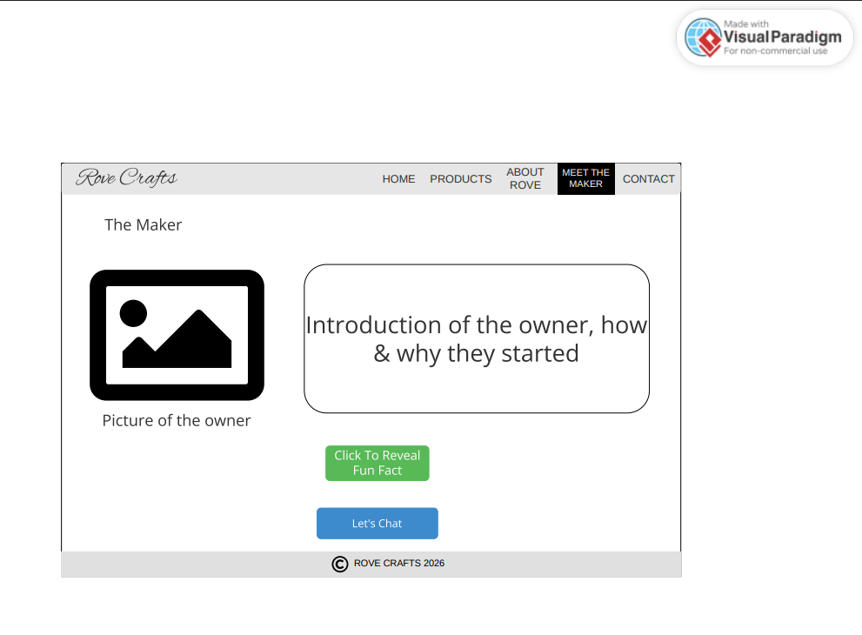

Figure 4: Meet the maker Page
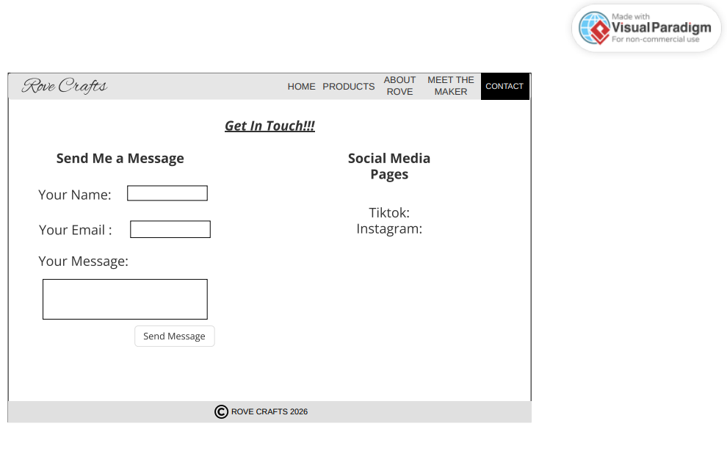
Figure 5: Contact Page

- Technical Brief

  - Languages

- HTML5: I'll be using it to build the core structure and layout of the website
- CSS3: I’ll be using it for styling. This includes the brand colours and typography which will show Rove Crafts’ aesthetic
- Bootstrap 5: will be used to ensure that my website is responsive. Since my target market mostly uses mobile devices, I need to ensure that my website works functionally on different mobile devices
- JavaScript: used to add interactivity, such as image enlargement for product viewing and the “Welcome” animation on the home page

  - Development & Graphics Software

- Visual Studio Code (VSCode): The code editor I’ll be using to write and debug the HTML, CSS, Bootstrap & JavaScript codes.
- Canva & CapCut: editing tools I’ll be using to create the graphics and edit the product photos on.
- Web Browsers (Chrome &Edge): I’ll be using these to test the website’s layouts and functionality in real-time on different screen sizes.

  - Hosting & Development

- GitHub: the website will be hosted here, specifically on GitHub pages, which provides an accessible URL for potential customers

- Quality Assurance
- Publishing & Promotion
- Future Developments/Recommendations

References
Arafah, B. & Hasyim, M., January,2022. Social Media as a Gateway to Information. Webology, 19(1).
Lou, L. & Koh, J., September 2018. Social Media Advertising Effectiveness. Asia Pacific Journal of Information Systems, Vol 28(no. 3).
Muralidhar, A. & Dr Raja, A. S., December 2019. Understanding the Purchase Intention Characteristics of Gen Z and Gen Y and Introspecting the Modern Demand Variables in Fashion Industry. International Journal of Scientific & Engineering Research, 10(12).
Sponcil, M. & Gitimu, P., 2013. Use of social media by college students. Journal of Technology Research .

